

American International University- Bangladesh

CSC 3222: Web Technologies

CO1.1 and CO2.1 Evaluation

Project Report

Summer 20-21

Project Title: Booking Tour Through Travel Agency Website

Section: E

|  |  |
| --- | --- |
| Student Name | Student Id |
| Syeda tasnim chowdhury | 19-41161-2 |
| Chowdhury, Ahnaf Jan | 16-32986-3 |
| Tanvir,Shofiul Alam | 18-36283-1 |
| Jannatul Ferdows Shoily | 18-38882-3 |

**Introduction:**

On this Project we Are going to Make a travel agency Website. A travel agency is a private retailer or public service that provides travel and tourism related services to the general public on behalf of accommodation or travel suppliers to offer different kinds of travelling packages for each destination. This Travel agencies Website project can provide outdoor recreation activities, airlines, car rentals, cruise lines, hotels, railways, travel insurance, package tours, insurance, guide books, VIP airport lounge access, arranging logistics for luggage and medical items delivery for travelers upon request, public transport timetables, car rentals, and bureau de change services. Travel agencies can also serve as general sales agents for airlines that do not have offices in a specific region. A travel agency main function is to act as an agent, selling travel products and services on behalf of a supplier. They do not keep inventory in-hand unless they have pre-booked hotel rooms or cabins on a cruise ship for a group travel event such as a wedding, honeymoon, or other group event.

**Background Study:**

The Tours and Travel Management System is a web based application. The main purpose of “Tours and travels management system ” is to provide a convenient way for a customer to book hotels, flight, train and bus for tour purposes. The objective of this project is to develop a system that automates the processes and activities of a travel agency. In this project, We will make an easier task of searching places and for booking train, flight or bus. . In the present system a customer has to approach various agencies to find details of places and to book tickets. This often requires a lot of time and effort. We provide approach skills to critically examine how a tourist visits and its ability to operate in an appropriate way when dealing with the consequences of tourism, locally, regionally, and nationally including visitor security and ecological influences. It is tedious for a customer to plan a particular journey and have it executed properly. The project ‘Tours and Travels Management System’ is developed to replace the currently existing system, which helps in keeping records of the customer details of destination as well as payment received.

**Requirement Analysis:**

1. User Category:

There are four types of Users here. They are:

* Admin
* Customer
* Verified customer
* Employee

In this project the “Admin” has the following features:

Feature List: 1. Customizable travel policies

One of the most important features in a travel management system is the travel policy. Even if office managers or travel managers book on behalf of travelers

### 2. Customizable approval workflows

Your travel management system should include approval workflows inside of the platform, so that if anything falls outside of policy, the person booking a trip can request approval and save their trip details (instead of sending an email and losing all their hard work of selecting the right itinerary). You should be able to set up these approval workflows however you want, such as picking different approvers for different teams and customizing the level of strictness

### 3. Extensive inventory

Your policy and approval workflows are really critical in helping you maintain travel compliance around the clock, but so is your access to inventory

### 4. Support included at no additional cost

Paying a fee for every support call is really old school and really expensive. Your travel management system should include support at no additional cost to you.

### 5. No redirects

When you’re booking a vacation and you get redirected, it’s annoying. It can also be a little nerve-wracking because you’re not sure if you should trust this new vendor you’re being redirected to.

### 6. Travel spend reporting

One of the most important features of any travel management system is the ability to report on business travel. Here are some things you’ll want to be able to track:

* Travel spend by time period
* Travel spend by department or team
* Amount of travel spend booked out of policy

### 7. Consolidated invoicing

The easiest way to track your business travel is to book it in one place. However, some travel management systems don’t act as a single vendor, meaning you’ll still have a lot of different invoices. To save time and hassle on business travel, choose a system that consolidates all of your monthly travel into a single vendor invoice.

### 8. Review the status of all trips in one place

The whole point of a travel management system is being able to consolidate travel. Let’s see how this plays out in a real-life scenario. Let’s say that 20 travelers are supposed to each book their own trip to upcoming events.   
  
As the travel manager, you should be able to login to your travel management platform and see…

* Who has successfully booked their trip within policy
* Who is requesting an out-of-policy booking and why
* Who has an in-progress trip (they’ve saved an itinerary but not completed the booking yet)
* Who hasn’t booked a trip

### 9. Easy booking, including self-booking for travelers

Even if you don’t plan on letting travelers book for themselves, you still want a smooth booking experience and great UX for the employees who are in charge of booking travel.

### 10. Methods of transportation that matter to you

You expect your travel management system to have flights and hotels, and most likely cars. But what about trains? If [trains are a common way that your employees travel](https://support.travelperk.com/hc/en-us/articles/360000717847-How-do-I-book-a-train-through-TravelPerk-), then you should choose a travel management system that includes them.

### 11. Save traveler information

Booking business travel doesn’t have to take 2 hours. When you save every traveler’s information in your travel management system (including legal name, travel document country and number, birthday, etc.), it can take a whole lot less time—minutes even.

### 12. No long term contracts

If you don’t like your travel management system, you shouldn’t be forced to use it.  
  
Popping champagne bottles at the end of long sales cycles is the old way. Trying a system out, seeing if you like it and leaving it if you don’t is the new way. When vetting the travel management platform, check that you don’t get locked in.

In this project the “Customer” has the following features:

In this project the “Verified Customer” has the following features:

* Login
* Booking
* Password Change
* Train Booking
* Bus Booking
* Plane Booking
* Launch Booking
* Check In
* Communicate with Agency
* Cancel Booking
* Refund
* Edit booking

In this project the “Employee” has the following features:

* Login
* Booking
* Train Booking
* Bus Booking
* Plane Booking
* Launch Booking
* Check Out
* Guide Customer
* Report
* Meet target
* Communicate with operator
* Upload record
* Deal with refund

Design:

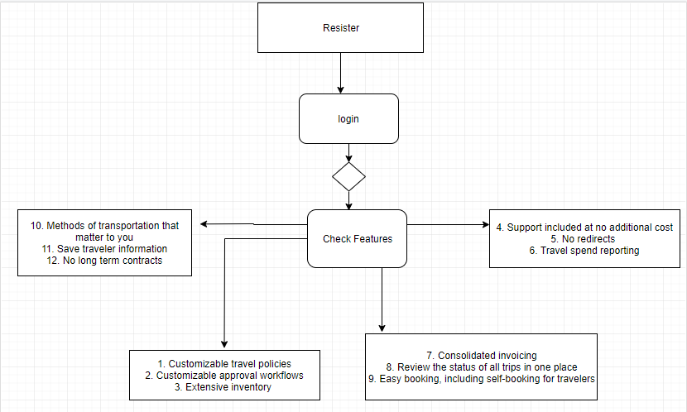

Tools Used:

To develop this project, we have used the following:

• Xampp

• Notepad++

• Git

• Firefox

**Impact of this Project:**

On This project we are going to make a travel agency website. Traveler Can Easily Book their Tour through This Website. Traveler can save their time and money by using this website. This website will offer real time data access, 24*7 interactions with customers, Minimize maintenance cost, Minimize order processing costs, Instant reservation or booking facilities of flights, tour packages etc. Traveler can simply search for hotels and book them online. They can view their account details, booking stage, seat number easily. Booking a ticket or cancelling a ticket becomes very simple. There is also feedback option so It's easy to check out what people say about this website. Simply This website will Make Travelers tour affordable.

**Limitations and Possible Future Improvements:**

1. There can be several limitations of this websites sometimes the tickets may get cancelled due to various reasons and it may become a hassle for the clients. Then the accommodations may not be up to the mark according to the client expectation. Sometimes the client might not get a fast response if there is no user replying to the client in the first place. There might be some draw backs as well in booking flights or any other transportation as it will be done by the agencies. Sometimes the cost can be more if it is booked through the websites than doing it manually.

On the other hand in order to improve this website we need to make sure to provide a user on the backend who can accommodate the client whenever needed. A real-time of the flights should be updated with the website so that no hassle of tickets getting cancelled will be faced. The accommodations should be well defined pictures of the accommodation should be in the website so that the client doesn’t get disappointed.

|  |  |  |  |  |  |
| --- | --- | --- | --- | --- | --- |
| CO1.1 and CO2.1 Evaluation: Project Report Evaluation | | | | | |
| Project Proposal  (5) | Background  Study  (5) | Requirement Analysis  (5) | Entity  Diagram  (5) | System Images  against the  Specification (5) | Total (25) |
|  |  |  |  |  |  |
|  | | | | | |